# “NEWS PAPER MANAGEMENT SYSTEM”

### A Project report submitted

**In the partial fulfillment the award of degree of**

**BACHELOR OF TECHNOLOGY**

**IN**

**COMPUTER SCIENCE AND ENGINEERING (2022-2023)**

**BY**

**G. SWAPTHIKA -211801410011**

**Under the esteemed Guidance of**

**Mrs. G. Rama Devi, M.Tech,(Ph.d),Asst. Professor**

**CENTURION UNIVERSITY SCHOOL OF ENGINEERING AND TECHNOLOGY**

**Rollavaka village, Tekkali mandal 535003**

**(2022-2023)**

##### CENTURION UNIVERSITY OF TECHNOLOGY AND MANAGEMENT

**ANDHRA PRADESH**

**(2019-2023)**

##### DEPARTMENT OF ELECTRONICS AND COMMUNICATION ENGINEERING

BONAFIDE CERTIFICATE

##### This is to certify that the project work entitled “NEWS PAPER MANAGEMENT SYSTEM” is a fulfillment of project workdone byG.SWAPTHIKA(REG.NO.211801410011 for the award the degree of BACHELOR OF TECHNOLOGY in ELECTRONIC AND COMMUNICATION ENGINEERING, CENTURION UNIVERSITY OF TECHNOLOGY AND MANAGEMENT, during the academic year 2022-2023.

INTERNALGUIDE HEAD OF THE DEPARTMENT

##### Mrs .G. Rama Devi Mr. K.Jogi Naidu sir

**Asst. Professor Asst. Professor**

**Dept. of CSE Dept. of ECE**

**EXTERNAL EXAMINER**

**ACKNOWLEDGEMENT**

It is with at most pleasure and excitement we submit our project partial fulfillment of the requirement for the award of Bachelor of Technology.

The project is a result to the cumulate efforts, support, guidance, encouragement and inspiration from many of those for whom we have to give our truthful honor and express gratitude through bringing out this project at the outset as per our knowledge.

I convey my special thanks to our project **Guide Mrs. G. Rama Devi(Asst. Professor)** who has guided, encouraged and tremendously supported me to enhance my knowledge with present working of this project to bring out enriching the quality of project.

I express my appreciativeness to **Mr. K.JOGINAIDU (Asst. Professor) and Head of the Department,** who facilitated us to providing the friendly environment which helped to enhance my skills in present project.

I would also like to extend my gratitude to **Dr. K. V. G. KRISHNA MURTHY, Dean-School of Engineering And Technology, Centurion University of Technology and Management** who has helped us to attain all the requirements of the project.

I convey my sincere thanks to **Dr. RAMANA RAO, Ph. D Registrar of Centurion University of Technology and Management** who provided us with an opportunity to take on project work in well-equipped laboratories of electronic and communicationDepartment in our college.

At the outset, we thank to **Sri. G.S.N.RAJU**, beloved **Vice Chancellor of Centurion University of Technology and Management** who is the back bone by providing for completion of this project, Thank you sir.

**DECLA****RATION**

I hereby declare that the project entitled **“NEWS PAPER MANAGEMENT SYSTEM”** submitted to the fulfillment of award the degree of **B-TECH (ECE)** in **CENTURION UNIVERSITY OF TECHNOLOGY AND MANAGEMENT**, **ANDHRA PRADESH.**

**G. SWAPTHIKA -211801410011**

ABSTRACT

The technology is not yet fully integrated with automation mechanisms for Distributing Newspapers. The distribution mechanism for online newspapers is

what we use. For Vendors and Customers who fall under the distributor's management. Based on the distribution of online newspapers utilizing technologies akin to the internet buying system. The Internet and

the usage of new technologies enhance the newspaper delivery system. Present-day newspapers are distributed by newspaper vendors manually, with the various issues with the manual system are described in more detail. There are several issues with manual approaches', including the high likelihood of adding

human error and other outside factors. These customer and newspaper delivery issues may both be resolved by using our system. Newspapers were once the lifeline of the nation and was hailed as the fourth estate for its sheer power in forming public opinion and creating revolution on many issues. The aim of this project is to optimize newspaper delivery system. his newspaper distribution system can be a good replacer for online manual technique of newspaper distribution.

Eg: news paper distribution,manual,

## TABLE OF CONTENTS

CERTIFICATE i

ACKNOWLEDGEMENT ii

ABSTRACT iii

TABLE OF CONTENTS iv

TABLE OF FIGURES v

1.INTRODUCTION 1

* 1. PURPOSE
  2. SCOPE
  3. ACRYONYMS
  4. OVERVIEW

2.REQUIREMENT SPECIFICATION 3

2.1 FUNCTIONAL REQUIREMENTS

2.2 NON FUNCTIONAL REQUIREMENTS

3.DESIGNING 8

4.IMPLEMENTATION 13

5.METHODOLOGY……………………………………………………………………………………………15

6.SOFTWARE ENVIRONMENT 16

7.FUTURE WORK…………………………………………………………………………………………………………………………………………….17

8.CONCLUSION……………………………………………………………………………………………………………………………………………….19

REFERENCES 35

## TABLE OF FIGURES

FIGURE3.1 CONTEXT DIAGRAM 9

FIGURE 3.2 DATA FLOW DIAGRAM LEVEL1 10

FIGURE 3.3 ENTITY RELATIONSHIP DIAGRAM 11

FIGURE 3.4 USE CASE DIAGRAM 12

**1.INTRODUCTION**

**Newspapers** were once the country's lifeline and were acclaimed as the fourth estate for their unmatched ability to shape public opinion and spark a revolution on a variety of problems. The project's goal is to improve the newspaper distribution system. This automated system for distributing newspapers might be a useful replacement for the laborious manual method. This management system for newspapers aids in online newspaper distribution.

When the administrator logs in, they may manage the newspaper online and create invoices. Once logged in, the vendor may also add the delivery guy and seek for client subscriptions.

The development of portal for **web based newspaper** generally means creating a website in which the management of all news item sent by crowd about any type of news & activities are done by the administrator where all people (viewers) can view and know all the relevant information about the knowledge which they seek,. In which web based in system can be done.

Paper Agency System is a circulation software and subscription management for newspaper and magazine distributors. News Paper Agency System It is a multiple newspaper subscription management. . It’s a multiple newspaper subscription distribution automation system that manages all newspaper and magazine distribution. This newspaper dissemination system is built for independent publishers and both small and large

**1.1PURPOSE**

1.The purpose of this document and project is to describe the requirements for the Newspaper Delivery System

2. A system with roles that can be controlled much like a genuine newspaper to keep a standardized, organized website.

3.we have provided registration and admin login to get registred by the customers.

4.The portal has basically three user parts where

**a)**one is registered user (authentication required) who can view.

**b)** add comment can have general discussion with another user

**c)**another is administrator (has an authentication) who will manage or control the website and other

user (no authentication required) can only view and search.

**1.2 SCOPE**

The website consists of basic pages from which the user can view and know the relevant information like history, upcoming. In other case, the administrator manages all the relevant actions for which the users can view properly and also make reports.

**1.3 DEFINITIONS, ACRONYMS AND ABBERIVATION**

**NDS-** Newspaper Delivery System.

**Report** - a statement of delivered newspaper.

**Admin** - administrative staff that work at reception desk.

**Login ID** - a user identification number to enter the system.

**Password** - a word that enables one to gain admission into the system.

**Web-based application** - an application that runs on the Internet.

**Sign up**- used to login at the first time of the website.

**HTML** - a query language to interrogate the system.

**SRS** - Software Requirements Specification.

**1.4 OVERVIEW**

The aims of this document is to formally describe the system’s high level requirements including functional requirements, design constraints, non-functional requirements, performance requirements, maintainability.

The following material is used in creating the website

🡪Visual studio- for writing the code

🡪html webserver- to display the website

Various techniques were used to elicit the requirements and we identified the needs, analyzed and refined them.

**2. REQUIREMENT SPECIFICATION**

The purpose of SRS (Software Requirement Specification) document is to describe the external behavior of the web based newspaper. It defines the operations, performance and interfaces and quality assurance requirement of the web based newspaper. The complete software requirements for the system are captured by the SRS (Software Requirement Specification).

**2.1. Functional Requirements:**

For documenting the functional requirements, the set of functionalities supported by the system are to be specified. A function can be specified by identifying the state at which the data is to be input to the system, its input data domain, the output data domain, and the type of processing to be carried on the input data to obtain the output data.

Basically the management parts are the functional requirements which are uploading details, search topic, edit option and user registration.

**Uploading Item Description**:

Uploading function can be done by the user who has registered on the website. When the user uploads an item and if it is a news item or forum is determined and edited by the administrators or editors and then it is displayed on the home page. A registered user can also add comment on other news as well.

**R1.1: Select upload option.**

**Input:** Upload item option.

**Output**:User will be prompted to enter the upload type

**R1.2: Select the type of item.**

**Input**: Users option from one of the following

R1.2.1 News item

R1.2.2 Book item

R1.2.3 magazines

**Output**:User will be prompted to enter item details according to the above item.

**R1.3: Check to display**

**Input**: Check whether the item is visible for the masses.

**Output**: We will be prompted to display item

**R1.4: Display the item(‘can edit only by admin’)**

**Input**:Edit the news item.

**Output**: The item is displayed on the screen.

**Processing**:

It is controlled by the editor and which checks whether the uploaded item is fit for the mass or not if it is then it display on screen if not then it is edited to make it visible for the mass then display on the screen of the website

**R2: Search topic which news paper you want to select or magazines**

Description: Search function does not require any authentication from its user so any user can perform this function. If an user searches for a news item then the news will be displayed on the screen if it related to the search topic.

**R2.1: Select search option**

Input: Search option.

Output: User will be prompted to enter the search topic.

**R2.2: Check for the search topic**

Input: Checks for the search topic related item.

Output: We will be prompted to display the items.

**R2.3 Display the item**

Input: Enter topic related to item.

Output: Display the item

**Processing:**

It checks for any item related to the search topic and displays it on the screen and if there is no item related to the topic is present then it will pop as no related item.

**R3: sign up or login in pages.**

**R3.1: Sign up with our details:**

**Input:** enter name ,email-id,password

**Output**: we will be promoted to next page

**R3.2: login page**

**Input:** email, password

**Output:** promoted to new page

After login page we get different parts in login page like:

🡪R3.2.1 profile

🡪R3.2.2submit request

🡪R3.2.3service status

🡪R3.2.4change password

🡪R3.2.5logout

**R3.2.1 profile**

**We have to click on profile**

**Input:** email,name

**Output:**we can promoted to new i.e updating the file

**R3.2.2 submit request**

**We have to click on submit request**

**Input:** Request Info

Description, Name

Address ,City, state ,code ,email ,mobile ,date

Submit, reset.

**Output:** we can submit the request or we can reset and promoted new website

**R3.2.3** **service status**

**By clicking on service status button**

**Input:** enter request id

**Output:** we get search the needed one

**R3.2.4** **Reset password**

**We have to click on change password**

**Input:** email , newpassword

**Output:** we can update the password or we can reset

**R3.2.5 logout**

**Input** :logout

**Output**: reached to home page

**Processing:** Here mainly in which login the page and for mainly to reset password,email

**R4 ADMIN AREA**

**R4.1: Admin area:**

**Login the page**

**Input:** email, password.

**Output:** login to the page(admin area)

By clicking on Admin area login

It displays

🡪Dash board

🡪work order

🡪Requests

🡪Availabilities

🡪Sales person

🡪Requesters

🡪Sell report

🡪Work Report

🡪Change password

🡪Log out

By clicking the each we get different links to develop further

**R4.2: Check for validity**

**Input:** Checks whether any other registered users have same information.

**Output:** We will be prompted to register successfully if it has different information or else its rejected.

**Processing:** It checks if the information submitted about the new user is similar to any other registered user if yes it rejects the user information if no then new user will be registered successfully.

R4.2: **contact us**

**Input**: Name, subject, E-mail

The customer can login the page when they need help customers

Head quarter and Home Branch is displayed to get help to customers

**2.2. Non-functional Requirements:**

These are the requirements that are not functional in nature.

Especially these are the constraints the system must work within.

• **Performance Requirements**: The system response time must be less than 30 seconds for the user interface. Or else the system will show TIMED OUT.

• **Reliability Requirements:** The system shall have a minimum uptime of 99 % excluding time pre-scheduled for maintenance and/or upgrades

. • **Safety Requirements:** All the system data must be backed up every day and the backup copies stored in another server at different location for disaster recovery.

**Quality Attributes**:

The source code for the system is well documented for ease of maintenance and upgrading the system in future.

**3.DESIGN**

Design phase deals with transforming the requirements, as described in the SRS document, into a form that is implemented using a programming language. The various designs of this system are shown as following:

### Data Flow Diagram:

Data Flow diagram is a graphical representation of flow of data throughout the information system. Data flow diagrams illustrate how data is processed by a system in terms of inputs and outputs.

**Name Notation Role**

Process Transforms incoming data flow to output data flow

Data Store Repositories of data in the system.

Dataflow Dataflow are pipelines through which packets of information flow.

External Entity

External entities are objects outside the system, with which the system communicate

1.**CONTEXT DIAGRAM**

Publish News

Account Details

Account Details

Add Comments

News Details

0.0

Feedback

User details

Web Based

News pape

Newspaper

General Discussion

Content Details

Edit Info.

View

Search

Users

Administrator

Other Users

**FIGURE 3.1 CONTEXT DIAGRAM**

**2.DATA FLOW LEVEL**

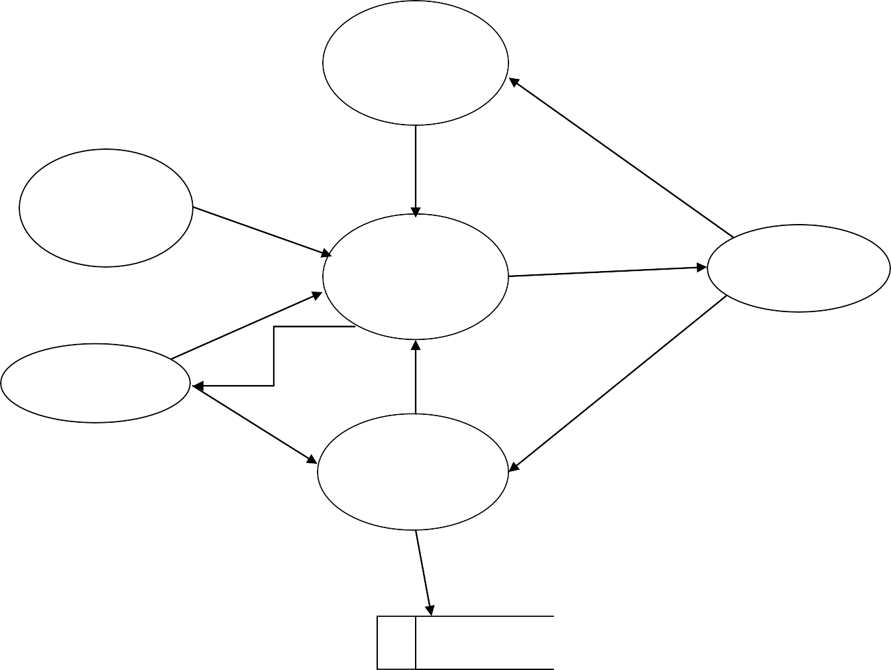

1.1

Upload item

Upload info.

1.6

Other user

activity

Search info.

1.2

Display info.

Manage detail

1.4

User activity

Edit info.

1.5

Admin activity

Manage info.

User info.

Acc. info

Acc. info

1.3

Register

Save data

Data base

**FIGURE 3.2 DATA FLOW LEVEL**

### Data Dictionary:

News Details :{Sports News + Education News + Business news…} User Details :{ User Id + Email Id + Password}

Content Details: {Email Id + Message}

Account Details :{ User+ Old Password + New

PasswordFeedback :{ Name+ Email+ Message}

View Detail :{ Headlines + Previous News}

Search Detail: {Topic + News}

**3.Entity Relationship Diagram:**

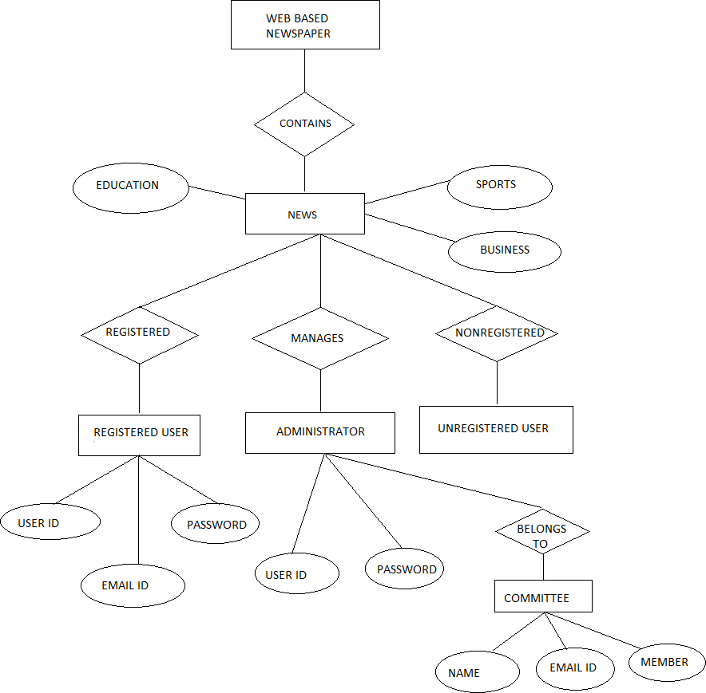

## **FIGURE 3.3 ENTITY RELEATIONSHIP DIAGRAM**

**4.Use case diagram:**

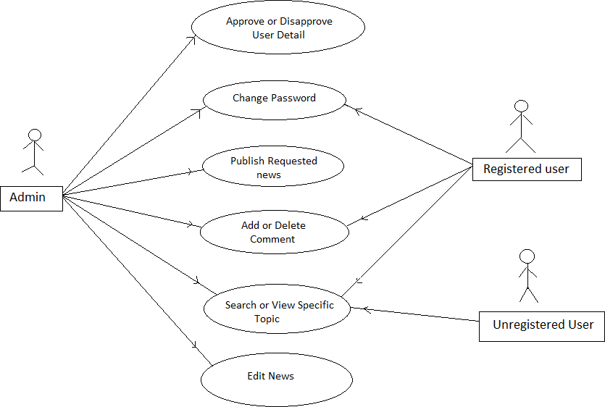

**FIGURE 3.4 USECASE DIAGRAM**

# **4.IMPLEMENTATION**

Implementation or execution in any project is done when the project planning is complete as detailed as possible.

In this phase it monitors everything that could jeopardize the project or part of it in another words the theory is being tested by implementation to make sure the data in the system changes according to the plan.In order to keep track of project plan and keep ourselves in control all the tool and steps involved are applied by the project manager. Steps in which all the tools are used:

* + Take action according to plan
  + Record and document all the work, changes & results
  + Analyze the result of action or changes made according to the plan

The steps involved here in this particular phase are:

* + Installation of Hardware and Software

Conversion of data

* + System Training
  + Documentation of the system

**Installation of hardware and software:**

Before implementation the hardware and the software required for debugging the system should be made fully operativeso the translation can occur smoothly which is one of the most critical and costly activities in the system development life cycle.

**Conversion of data:** As the old system is converted into new system similarly the data from the old system should also be converted to run in the new system with in new format. I this step the recovery procedures are needed to be fully defined and also the database isconfigured with security.

**System training:** All the programs of the system are loaded onto the computer systems of the user during this step. After loading the system we check by whether the project is under the control of the user and works according to the plan.

To confirm the above sentence we need to complete the following steps:

* + To execute the package
  + To pass the data
  + To process the data
  + To take out the reports/records

As the new system is completely trained about the computerized system then the working is also change from manual to computerized working andthe process is called „Changeover‟.

There are few strategies which described for changeover of the system below:

1. Direct changeover
2. Parallel run
3. **Direct Changeover:**
4. Thenewsystem needs complete training and testing when it completely replaced on the old system due to uncertain approach of the system.
5. **Parallel run*:***

When computerized and manual systems are implemented simultaneously for some defined periodthen the same information is processed by both the systems. This strategy is costly but not very risky.

This is very costly because:

* + Manual results can be compared with the results of the computerized system.
  + The operational work can be doubled.

Failure of the computerized system at the early stage does not change the working of the organization, because the manual system goes on, as it used to do.

**5. METHODOLOGY**

The application of the system is to be designed as per the needs if customer as well as vendors.

The protocol for the same is given in step by step format:

• Step 1: Registration and authentication for Vendors and Customers.

• Step 2: Selection of services and schemes.

• Step3: Allocation of areas and services to customers and Vendors.

• Step 4: Distributor places orders to companies.

• Step 5: Company delivers the order.

• Step 6: Distributor distributes hardcopy to vendors and softcopy to customer’s accounts.

• Step 7: Vendor distributes hardcopy to customers.

• Step 8: Payments can be made to respective vendors or by credit cards.

• Step 9: Daily payment is currently being made by - Customer to vendor - Vendor to distributer - Distributor to company

**6. SOFTWARE ENVIRONMENT**

6.1 Visual Studio® 2008 Overview Microsoft® Visual Studio® 2008 enables developers to quickly produce linked apps that provide the best quality, and richest user experiences,

therefore delivering on Microsoft's vision of smart client applications. Organizations will find it simpler than ever with Visual Studio 2008 to collect and analyse data to support them in making wise business choices. With the aid of Visual Studio 2008, businesses of all sizes can quickly produce applications that make use of Windows Vista™ and the 2007 Office system and are safer, more manageable, and more dependable. Visual Studio 2008 delivers key advances for developers in three primary pillars:

• Rapid application development.

• Effective team collaboration.

• Breakthrough user experiences

• Developing Smart Client Applications.

• Creating Microsoft Office Applications.

• Developing Windows Vista Applications

. • Effective Data Management.

• Facilitating Fresh Web Experiences.

• IntelliSense both enhance the development process

**6.2 coding:**

The objective of coding phase for a given design is to implement the design in best way possible. In this phase design of the system is translated into code in a programming language. The coding phase affects the maintenance and testing phase of the system development life cycle process. Testing and maintenance effort reduces if the code is well written.

HTML (Hypertext Markup Language) is the main markup language for displaying web pages and other information that can be displayed in web browser. HTML written in the form of the HTML elements consisting of tags enclosed in angle brackets with in the web page content.

The purpose of the web browser is to read HTML documents and compose them into visible web pages.The browser never displays the HTML tags these tags are used to interpret the content of the pages.

**7. FUTURE SCOPE**

1.This paper can be implemented for the same system as that of milk distribution which also

problems.

2.Currently the software does not support for any issue regarding the paper stalls as the number of copies may vary as per the calendar. This can be improved upon by having the observation over the stall records of newspaper being sold as per days or weeks.

3. The software is currently meant to work only for distributor and vendors. This can be updated in future for stall vendors.

4.We can also provide extra facilities such as SMS alert, e papers and videos of recent news for respective customers

5.If we can upload different news papers in drive which can be helpful to see by customers

**8.CONCLUSION:**

The literature review that was carried out to acquire data for this study has given us insight into the difficulties developers confront while trying to successfully implement any project in a brand

would be significant in the field of newspaper distribution because of the numerous benefits networking and inline transactions offer. We have also found a solution to the is

1. Since we use a database system to store all of our records, the issue of paper copies may be identified.

2. The usage of online databases and electronic publication b

3. This paper is an attempt to produce a platform for Vendors and Customers to have interactions within each other for important purposes such as payment and subscription of services and to find any knowledge by them.

**REFERENCES**

1. *Fundamentals of Software Engineering,*Rajiv Mall,New Delhi: PHI Learning limited, 2003
2. Paul Nielsen, *SQL Server 2005 Bible.* Paul Nielsen, New Delhi: Wiley, 2006
3. *HTML, and CSS Bible.* Bill Karow, Chuck White, Steven M. Schafer Bryan Pfaffenberger, New York: Wiley 2004
4. <http://en.wikipedia.org/wiki/Software_engineering>
5. <http://www.w3schools.com/html/html_intro.asp>